Civil war in Sierra Leone

UNSC Resolution: | 1436
Date of adoption: | 24 September 2002
Operative paragraph: | 5
Demand number: | 2

Megan MacKenzie

Wording of demand

seek actively the urgently needed additional resources for reintegration

List of addressees of the demand

Government of Sierra Leone

Short-term compliance

Description of the addressee(s)’ conduct
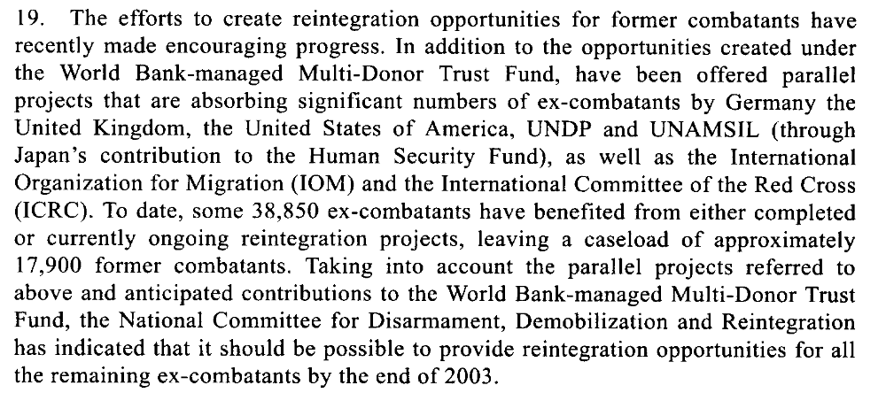

Assessment

Short-term compliance
No or marginal compliance (1) | Medium low compliance (2) | x Medium high compliance (3) | Full or almost full compliance (4)

Considerations underlying the assessment

The Secretary General’s report does not directly address funding but it is clear from the report that the Secretary General is pleased with the progress of the reintegration process and the manner in which the Government has been addressing reintegration.

Medium-term compliance

Description of the addressee(s)’ conduct

19. In the meantime, the Government of Sierra Leone, with the assistance of the
World Bank, is making arrangements to conduct an assessment of the effectiveness
of the overall disarmament, demobilization and reintegration programme. In this
connection, it should be noted that the main objective of the just-completed
programme in Sierra Leone was to provide ex-combatants with some skills through
very short-term training, as well as tools and a minimum amount of financial
resources to enable them to start a new life in civilian communities. As such, the
disarmament, demobilization and reintegration programme contributed immensely
to the stabilization of the country in the immediate aftermath of the war. However,
long-term community reintegration of the ex-combatants will depend on
employment opportunities, which must come from sustained economic growth.
20. It is also generally acknowledged that women combatants did not adequately
benefit from the disarmament, demobilization and reintegration programme,
particularly because the fast-tracking of the cantonment period resulted in a loss of
focus on special programmes intended for women.

Assessment

Medium-term compliance
No or marginal compliance (1) | Medium low compliance (2) | x Medium high compliance (3) | Full or almost full compliance (4)

Considerations underlying the assessment

It is clear from this report and from other sources that the reintegration process in Sierra Leone was not perfect; however, it was completed within this time frame with relative success.

Depth of demand

Assessment

Level of depth of demand
x Low depth of demand (1) | Medium depth of demand (2) | High depth of demand (3)

Considerations underlying the assessment
It was in the interests of the Government of Sierra Leone to find more resources for the reintegration process. Furthermore, the Government had support and encouragement from multiple international sources at this time.

Level of confidence about coding decisions

Level of confidence about coding decision
Extremely high | x High | Moderate

Comments to IPI (if any)

Civil war in Sierra Leone

UNSC Resolution: | 1436
Date of adoption: | 24 September 2002
Operative paragraph: | 7
Demand number: | 1

Megan MacKenzie

Wording of demand

accelerate the consolidation of civil authority and public services throughout the country, and strengthen the operational effectiveness of the security sector

List of addressees of the demand

Government of Sierra Leone

Short-term compliance

Description of the addressee(s)’ conduct

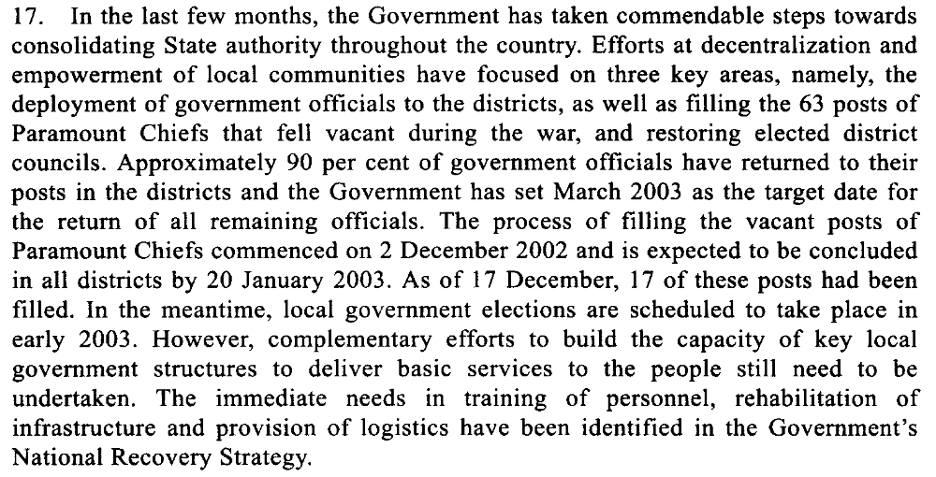

Assessment

Short-term compliance
No or marginal compliance (1) | Medium low compliance (2) | x Medium high compliance (3) | Full or almost full compliance (4)

Considerations underlying the assessment

The Secretary-General’s report specifically mentions that the Government has achieved major gains in relation to its authority in the country. It is mentioned that there are still several areas that the Government must work on; however, overall it appears that the Government has complied with this demand.

Medium-term compliance

Description of the addressee(s)’ conduct

22. Government officials from the relevant line ministries have been deployed in all 12 administrative districts of the country, and paramount chiefs have returned to their chiefdoms. The 64 paramount chief posts that fell vacant during the conflict were filled through elections held from 2 December 2002 to 24 January 2003. The presence of a better-equipped and more disciplined national police force is now visible in the provinces and, as indicated earlier, district and provincial security committees are being set up throughout the country.
23. Magistrate courts have been rehabilitated in all districts, and they are now sitting in the district and provincial headquarters, albeit with inadequate coverage. The recruitment of judges and magistrates has been hampered by the existing unattractive conditions of service. There are only five magistrates assigned to service a total of 12 districts. As a temporary measure, justices of the peace have been trained, with the support of UNDP, and deployed to some 18 locations where they perform judicial functions under the supervision of those magistrates.
24. Considering that only two years ago the extent of State authority was limited to about one third of the country, the progress made in re-establishing government administrative, security and judicial structures throughout the country is remarkable. Nonetheless, the capacity of those structures to function effectively remains severely limited due to the lack of logistics, infrastructure and qualified personnel. There is also concern that the district councils expected to be elected in May will likely face similar constraints, which could render ineffectual the efforts to decentralize the functions of the central Government. However, the World Bank, the Department for International Development, UNDP, the European Union and the United States Agency for International Development have indicated that they would provide capacity-building support to the councils and to the decentralization process in general.

Assessment

Medium-term compliance
No or marginal compliance (1) | Medium low compliance (2) | x Medium high compliance (3) | Full or almost full compliance (4)

Considerations underlying the assessment

There remained some concerns regarding state authority- particularly in terms of logistical support and its long-term capacity- however, the Government of Sierra Leone achieved major successes in terms of extending its authority within this time frame.

Depth of demand

Assessment

Level of depth of demand
x Low depth of demand (1) | Medium depth of demand (2) | High depth of demand (3)

Considerations underlying the assessment
It was in the Government’s interests to continue to extend its authority and did not require them to alter their behavior significantly.

Level of confidence about coding decisions

Level of confidence about coding decision
Extremely high | x High | Moderate

Comments to IPI (if any)

Civil war in Sierra Leone

UNSC Resolution: | 1436
Date of adoption: | 24 September 2002
Operative paragraph: | 8
Demand number: | 1

Megan MacKenzie

Wording of demand

set out and implement urgently a policy to regulate and control diamond mining activities

List of addressees of the demand

Government of Sierra Leone

Short-term compliance

Description of the addressee(s)’ conduct

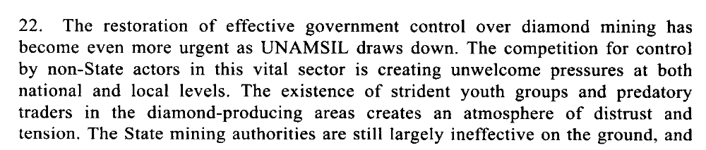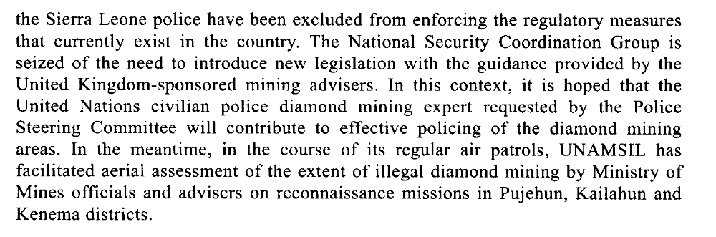

Assessment

Short-term compliance
No or marginal compliance (1) | x Medium low compliance (2) | Medium high compliance (3) | Full or almost full compliance (4)

Considerations underlying the assessment

It is clear that efforts had been made to extend Government authority in the diamond regions. Despite these efforts, there remained a high degree of lawlessness, corruption, and illicit activities in the diamond regions.

Medium-term compliance

Description of the addressee(s)’ conduct

25. The Government has taken important measures to reassert its control over diamond mining. In December 2004, the Cabinet approved a new core minerals policy that seeks to create an enabling legal, fiscal and institutional framework for the development of the country’s mineral wealth and prevent the use of natural resources to finance conflict and other illegal activities. Specific steps taken by the Government in this context include the establishment of a diamond crime, intelligence and investigation unit within the Sierra Leone police; vigorous law enforcement measures, including the deployment of mine monitors and wardens in mining areas; and incentives, such as the establishment of the Diamond Areas Community Development Fund, to encourage legal mining.
26. Furthermore, the 1994 Minerals Act has been amended to ensure stricter penalties for the illegal possession and smuggling of diamonds. In addition, UNAMSIL, jointly with the officials of the Ministry of Mineral Resources and the Sierra Leone police, conducted aerial surveys and ground patrols of mining areas throughout the country. The High-level Steering Committee on Diamonds also continues to coordinate efforts aimed at improving the governance and development of the diamond sector. As a result of these and other measures, the number of diamond-mining licences issued rose from 900 in June 2002 to 2,091 by the end of 2003, while official diamond exports increased from $10 million in 2000 to $76 million in 2003.
27. Nonetheless, the diamond sector still faces many serious challenges. More than 50 per cent of diamond-mining activities in the country remain unlicensed. In addition, diamond-mining rights and boundaries continue to be a major source of disputes among chiefdoms, and the large numbers of youths engaged in mining activities, as well as the largely unregulated power of chiefdom authorities to issue mining licences, present obstacles for potential investors. The use of child labour in the mines also continues to pose a serious challenge for Sierra Leone, despite the new policy prohibiting this practice.
28. The increase in legal mining activities, in particular the recent resumption of kimberlite mining in Koidu, is expected to have a positive impact on the country’s economy. However, the concerns expressed by many Sierra Leoneans about the environmental impact of the kimberlite mining, as well as alluvial mining, should be seriously addressed by the Government. In addition, it should be emphasized that bringing diamond mining under effective control is a long-term effort that will also require active community involvement and international support.

Assessment

Medium-term compliance
No or marginal compliance (1) | Medium low compliance (2) | x Medium high compliance (3) | Full or almost full compliance (4)

Considerations underlying the assessment

It is evident from this report that the Government had made more obvious gains in this area. The report mentions specific steps the Government took to extend its authority in the diamond regions and to regulate the sales of diamonds, including the establishment of a diamond crime, intelligence and investigation unit within the Sierra Leone police; vigorous law enforcement measures, including the deployment of mine monitors and wardens in mining areas.

Depth of demand

Assessment

Level of depth of demand
x Low depth of demand (1) | Medium depth of demand (2) | High depth of demand (3)

Considerations underlying the assessment

Gaining control of the diamond region and regulating the sales of diamonds was in the interests of the Government for security reasons as well as for revenue purposes.

Level of confidence about coding decisions

Level of confidence about coding decision
Extremely high | High | Moderate

Comments to IPI (if any)

Civil war in Sierra Leone

UNSC Resolution: | 1436
Date of adoption: | 24 September 2002
Operative paragraph: | 12
Demand number: | 2

Megan MacKenzie

Wording of demand

continue dialogue and implement their commitments to building regional peace and security

List of addressees of the demand

Government of Sierra Leone

Short-term compliance

Description of the addressee(s)’ conduct

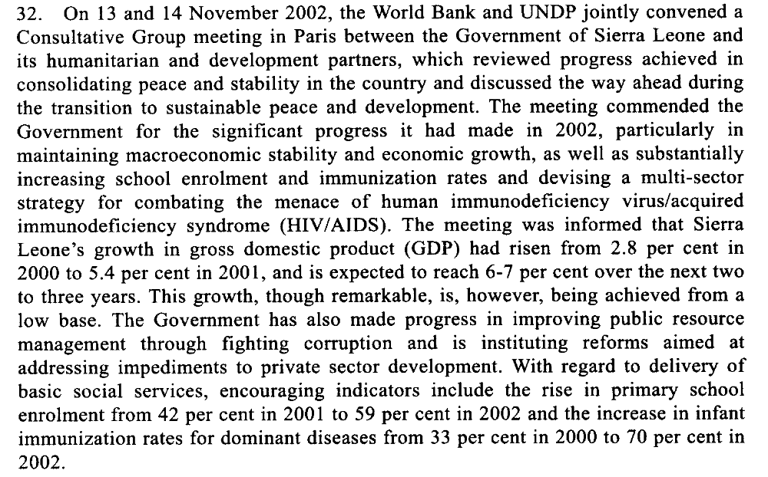

Assessment

Short-term compliance
No or marginal compliance (1) | Medium low compliance (2) | Medium high compliance (3) | x Full or almost full compliance (4)

Considerations underlying the assessment

The Government of Sierra Leone shows strong signs of their commitment to peace. They were commended for their efforts in the areas of education, reintegration, fighting corruption and governance.

Medium-term compliance

Description of the addressee(s)’ conduct

105. Sierra Leone is at a crossroads. The carefully calibrated exit strategy for UNAMSIL that was approved by the Security Council after the national elections in 2002 has yielded significant benefits for the country. In particular, the extended presence of the Mission has created a stable security environment and given the Government the opportunity to consolidate the peace and promote national recovery. I would like to commend President Kabbah and his Government for their efforts to make the most of this unique window of opportunity.

Assessment

Medium-term compliance
No or marginal compliance (1) | Medium low compliance (2) | Medium high compliance (3) | x Full or almost full compliance (4)

Considerations underlying the assessment

Depth of demand

Assessment

Level of depth of demand
x Low depth of demand (1) | Medium depth of demand (2) | High depth of demand (3)

Considerations underlying the assessment

Level of confidence about coding decisions

Level of confidence about coding decision
Extremely high | x High | Moderate

Comments to IPI (if any)

Civil war in Sierra Leone

UNSC Resolution: | 1436
Date of adoption: | 24 September 2002
Operative paragraph: | 13
Demand number: | 1436.1313

Megan MacKenzie

Wording of demand

maintain intensive patrolling of the border with Liberia

List of addressees of the demand

Government of Sierra Leone

Short-term compliance

Description of the addressee(s)’ conduct

“The conflict in Liberia remains a major concern for sustained stability in Sierra Leone. During the month of November, there was an upsurge of armed raids by Liberians searching for food in Sierra Leonean villages in the border areas”

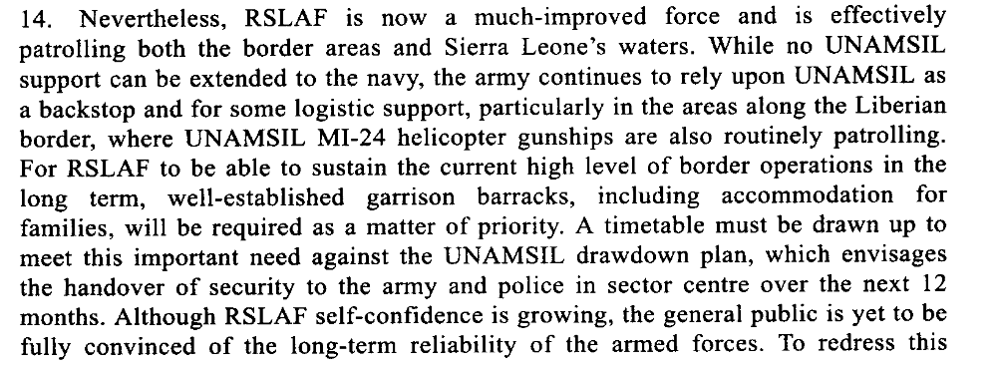

Assessment

Short-term compliance
No or marginal compliance (1) | Medium low compliance (2) | x Medium high compliance (3) | Full or almost full compliance (4)

Considerations underlying the assessment

Despite evidence of border insecurities, the Government showed that it was committed to monitoring the border with Liberia and dedicated forces for this task.

Medium-term compliance

Description of the addressee(s)’ conduct

The military (RSLAF) is faring better [than the police], even though it is also short on equipment, housing and training. Its performance in response to border incursions occasioned by the Liberian civil war has been erratic and at times unreliable.

8. UNAMSIL is also providing advice to Sierra Leone police in such key specialized areas as cross-border policing, airport security, criminal intelligence, policy and planning, family support and juvenile justice, while the United Kingdom of Great Britain and Northern Ireland and UNDP are leading the efforts to equip the police and rehabilitate the police infrastructure throughout the country. With the support of UNAMSIL, the police force has now established a diamonds crime intelligence and investigation unit, but efforts to recruit a United Nations civilian police diamond adviser have not been successful.

Assessment

Medium-term compliance
No or marginal compliance (1) | x Medium low compliance (2) | Medium high compliance (3) | Full or almost full compliance (4)

Considerations underlying the assessment

In the long term, border security was still a security issue for Sierra Leone and the Government required assistance from other parties to monitor the border.

Depth of demand

Assessment

Level of depth of demand
Low depth of demand (1) | x Medium depth of demand (2) | High depth of demand (3)

Considerations underlying the assessment

Although it was in the interests of the Government to monitor the border, due to the security situation in Liberia and the crossover of fighters from Liberia to Sierra Leone throughout the war, it was difficult to secure and monitor this border.

Level of confidence about coding decisions

Level of confidence about coding decision
Extremely high | x High | Moderate

Comments to IPI (if any)

Civil war in Sierra Leone

UNSC Resolution: | 1436
Date of adoption: | 24 September 2002
Operative paragraph: | 14
Demand number: | 1

Megan MacKenzie

Wording of demand

pay special attention to the needs of women and children affected by the war, as outlined in paragraphs 47 to 48 of the report of the Secretary-General of 5 September 2002 (S/2002/987)

List of addressees of the demand

Government of Sierra Leone

Short-term compliance

Description of the addressee(s)’ conduct

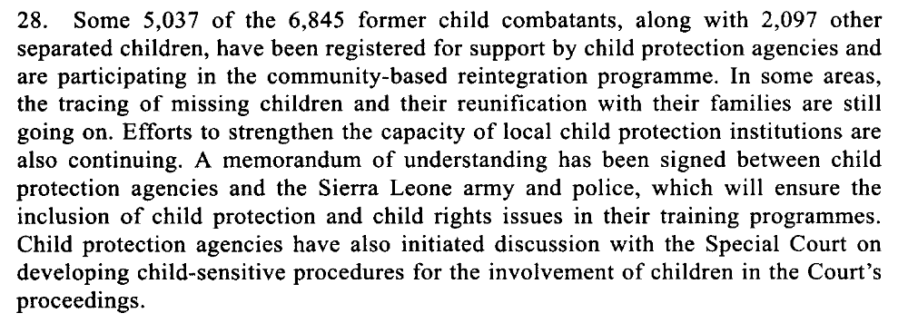

Assessment

Short-term compliance
No or marginal compliance (1) | Medium low compliance (2) | Medium high compliance (3) | x Full or almost full compliance (4)

Considerations underlying the assessment

Child soldiers were given special attention and special agencies and measures were taken to address the needs of children post-conflict.

Medium-term compliance

Description of the addressee(s)’ conduct

20. It is also generally acknowledged that women combatants did not adequately
benefit from the disarmament, demobilization and reintegration programme,
particularly because the fast-tracking of the cantonment period resulted in a loss of
focus on special programmes intended for women. No provision was made for
female camp followers, most of whom had been abducted by the combatants.
Women in this category feel stigmatized and have few options for improving their
lives. It is estimated that some 1,000 women and girls who missed out on
disarmament, demobilization and reintegration are still living with former rebel
commanders. Special programmes have been developed by the United Nations
Children’s Fund (UNICEF) and other agencies, which include counselling, family
tracing, mediation and skills training, in order to assist this group.
21. Preliminary assessments by UNAMSIL indicate, however, that the majority of
the 6,845 child combatants who were demobilized have now been reunited with their
families. Some 3,000 have been absorbed into the community educational
investment programme run by UNICEF. The Sierra Leone model for the
demobilization and reintegration of child combatants is widely considered as
success that could be applied to other peacekeeping operations. Nonetheless, it is
important to stress that the successful reintegration of children is a long-term
process that requires sustained and continued support. Thus, current funding
shortfalls in this area need to be addressed.

Assessment

Medium-term compliance
No or marginal compliance (1) | x Medium low compliance (2) | Medium high compliance (3) | Full or almost full compliance (4)

Considerations underlying the assessment
Women were grossly underrepresented in the DDR and there were limitations to the funding available for children. In addition, sexual violence remained high after the war and little resources were dedicated to survivors of sexual violence.

Depth of demand

Assessment

Level of depth of demand
x Low depth of demand (1) | Medium depth of demand (2) | High depth of demand (3)

Considerations underlying the assessment

Level of confidence about coding decisions

Level of confidence about coding decision
Extremely high | High | Moderate

Comments to IPI (if any)

Civil war in Sierra Leone

UNSC Resolution: | 1436
Date of adoption: | 24 September 2002
Operative paragraph: | 15
Demand number: | 1

Megan MacKenzie

Wording of demand

take the necessary measures to bring to justice their own nationals responsible for such crimes [sexual abuse and exploitation of women and children perpetrated by persons employed by UNAMSIL]

List of addressees of the demand

Government of Sierra Leone

Short-term compliance

Description of the addressee(s)’ conduct

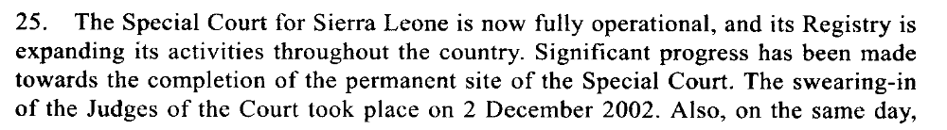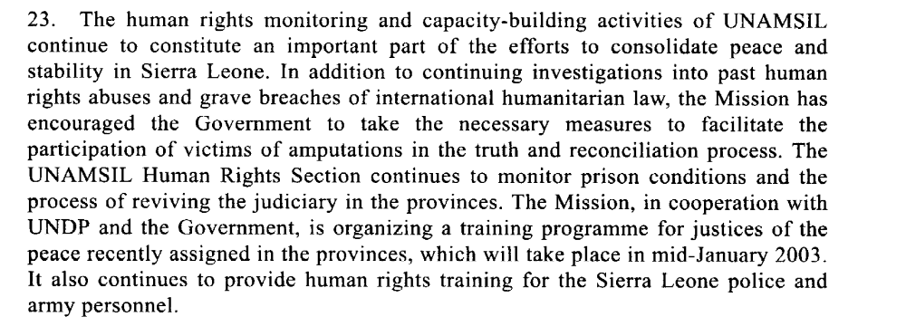

Assessment

Short-term compliance
No or marginal compliance (1) | Medium low compliance (2) | x Medium high compliance (3) | Full or almost full compliance (4)

Considerations underlying the assessment
At this time the Government had established several mechanisms, including the Special Court and the Human Rights Commission to investigate and bring justice to perpetrators in the country.

Medium-term compliance

Description of the addressee(s)’ conduct

42. The overall human rights situation in Sierra Leone has improved since the end of the war in early 2002. Steps are being taken to increase access to justice, although major challenges remain in this area. Substantial improvements in the conditions of detention in police stations and prisons have been achieved due to regular monitoring. Similar monitoring of magistrate courts has also had a positive impact on the backlog of cases pending before the courts. The Truth and Reconciliation Commission has completed its work and is now finalizing its report, which is expected to be published in May 2004. Many Sierra Leoneans acknowledge that the Truth and Reconciliation Commission has had the desired cathartic effect. However, views are somewhat divided on whether the work of the Special Court will have a similar healing impact.
43. Despite the above-mentioned gains, there are key human rights issues that need to continue to be monitored and addressed. In particular, the causes and effects of the human rights crisis emanating from a decade of war are yet to be adequately addressed. In this context, many Sierra Leonean and international stakeholders have expressed concern about the human rights implications of the weak capacity of the country’s justice system. This and other challenges, coupled with corrupt practices, impede the effective, efficient and equitable delivery of justice.
44. Reform of the justice sector needs to be pursued with the aim of ensuring access to justice for the poor, rural communities and vulnerable segments of the society, in particular women and children. The United Kingdom-sponsored Safety, Security and Access to Justice programme contributes to these important objectives through support for building the capacity of the justice sector. However, concern has also been expressed about the lack of progress on law review and reform. Old laws that include gender and other forms of discrimination are still on the books. In addition, the Government needs assistance on law reporting. Judicial authorities continue to have little or no access at all to current legislation and jurisprudence. The Minister of Justice and the Attorney-General informed the assessment mission that the last law report was issued in 1973 and emphasized that the publication of the country’s laws is vital to the promotion of the rule of law.
45. Violence against women, including sexual exploitation, as well as discrimination against women in law and in practice and the low rate of participation of women and youth in the political and administrative affairs of the country, needs to be addressed.

Assessment

Medium-term compliance
No or marginal compliance (1) | Medium low compliance (2) | x Medium high compliance (3) | Full or almost full compliance (4)

Considerations underlying the assessment

The TRC, Special Court and the Human Rights Commission were still in process; however, the Government was still lacking some of the logistical support needed to investigate and bring perpetrators to justice.

Depth of demand

Assessment

Level of depth of demand
Low depth of demand (1) | x Medium depth of demand (2) | High depth of demand (3)

Considerations underlying the assessment

Due to the length of the war and the number of perpetrators, bringing justice to perpetrators required significant resources and logistical commitments.

Level of confidence about coding decisions

Level of confidence about coding decision
Extremely high | x High | Moderate

Comments to IPI (if any)

Civil war in Sierra Leone

UNSC Resolution: | 1436
Date of adoption: | 24 September 2002
Operative paragraph: | 16
Demand number: | 2

Megan MacKenzie

Wording of demand
continue to cooperate to this end to fulfil their commitments under the Abuja Ceasefire Agreement of 10 November 2000 (S/2000/1091)

List of addressees of the demand
Government of Sierra Leone, Revolutionary United Front

Short-term compliance

Description of the addressee(s)’ conduct
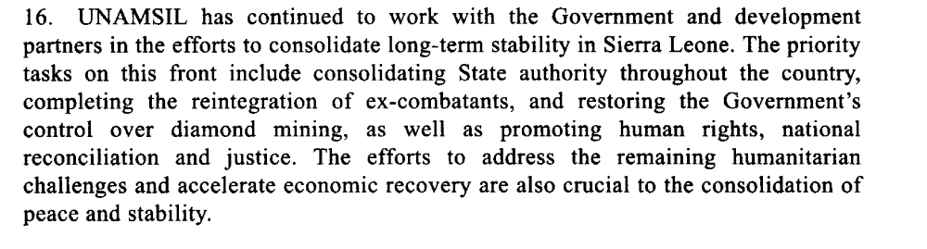

Assessment

Short-term compliance
No or marginal compliance (1) | Medium low compliance (2) | Medium high compliance (3) | x Full or almost full compliance (4)

Considerations underlying the assessment

Major strides were made in terms of reintegration, justice, and the consolidation of authority during this time.

Medium-term compliance

Description of the addressee(s)’ conduct

105. Sierra Leone is at a crossroads. The carefully calibrated exit strategy for
UNAMSIL that was approved by the Security Council after the national elections in
2002 has yielded significant benefits for the country. In particular, the extended
presence of the Mission has created a stable security environment and given the
Government the opportunity to consolidate the peace and promote national recovery.
I would like to commend President Kabbah and his Government for their efforts to
make the most of this unique window of opportunity.

Assessment

Medium-term compliance
No or marginal compliance (1) | Medium low compliance (2) | Medium high compliance (3) | x Full or almost full compliance (4)

Considerations underlying the assessment

Depth of demand

Assessment

Level of depth of demand
x Low depth of demand (1) | Medium depth of demand (2) | High depth of demand (3)

Considerations underlying the assessment

Level of confidence about coding decisions

Level of confidence about coding decision
Extremely high | High | Moderate

Comments to IPI (if any)

United Nations Secretary-General. Sixteenth report of the Secretary General on the United Nations Mission in Sierra Leone 24 December 2002.
United Nations Secretary-General. Twenty-first report of the Secretary-General on the United Nations Mission in Sierra Leone. 19 March 2004.
United Nations Secretary-General. Sixteenth report of the Secretary General on the United Nations Mission in Sierra Leone 24 December 2002.
United Nations Secretary-General. Twenty-first report of the Secretary-General on the United Nations Mission in Sierra Leone. 19 March 2004.
United Nations Secretary-General. Sixteenth report of the Secretary General on the United Nations Mission in Sierra Leone 24 December 2002.
United Nations Secretary-General. Twenty-first report of the Secretary-General on the United Nations Mission in Sierra Leone. 19 March 2004.
United Nations Security Council, 'Humanitarian, Recovery and Development Challenges' Sixteenth Report of the Secretary-General on the United Nations Mission in Sierra Leone, (S/2002/1417, 24 December 2002), pp.9.
United Nations Secretary-General. Twenty first report of the Secretary General on the United Nations Mission in Sierra Leone 19 March 2004.
United Nations Security Council, 'Strengthening the Security Sector' Sixteenth Report of the Secretary-General on the United Nations Mission in Sierra Leone, S/2002/1417, 24 December 2002.
United Nations Secretary-General. Sixteenth report of the Secretary General on the United Nations Mission in Sierra Leone 24 December 2002.
International Crisis Group. Sierra Leone: The State of Security and Governance. ICG Africa Report No 67. Freetown/London/Brussels. 3 September 2003. P5.
U.N. Security Council, ’25/26 Restoration of Government Control over diamond mining activities’, in Twenty-first report of the Secretary-General of the United Nations Mission in Sierra-Leone, (S/19/03/2004/228), pp. 3.
United Nations Security Council, 'Humanitarian, Recovery and Development Challenges', Sixteenth Report of the Secretary-General on the United Nations Mission in Sierra Leone. (S/2002/1417, 24 December 2002),pp.8.
United Nations Secretary-General. Twenty first report of the Secretary General on the United Nations Mission in Sierra Leone 19 March 2004.
United Nations Secretary-General. Sixteenth report of the Secretary General on the United Nations Mission in Sierra Leone 24 December 2002.
United Nations Secretary-General. Twenty-first report of the Secretary-General on the United Nations Mission in Sierra Leone. 19 March 2004.
United Nations Secretary-General. Sixteenth report of the Secretary General on the United Nations Mission in Sierra Leone 24 December 2002.
United Nations Secretary-General. Twenty first report of the Secretary General on the United Nations Mission in Sierra Leone 19 March 2004.

